**Adventure Works Data Integration and Analytics Pipeline**

ADF pipeline pulls daily sales data from on-prim AdventureWorksLT2022, stages it in ADLS, cleans and transforms it with Mapping Data Flow, aggregates by region and customer, and loads it into Azure SQL for Power BI dashboards. The pipeline logs all runs, sends Teams alerts, and is fully parameterized.

Build an end-to-end ADF pipeline that:

1. Extracts data from your on-prim AdventureWorksLT2022 SQL Server.
2. Loads it into Azure Data Lake Storage (ADLS) as raw data (Bronze Layer).
3. Cleanses and transforms it into Silver and Gold layers using Data Flow.
4. Loads final curated data into Azure Synapse / Azure SQL Database for reporting.
5. Automates the workflow with Triggers, Parameters, Variables, Logging, and Monitoring.

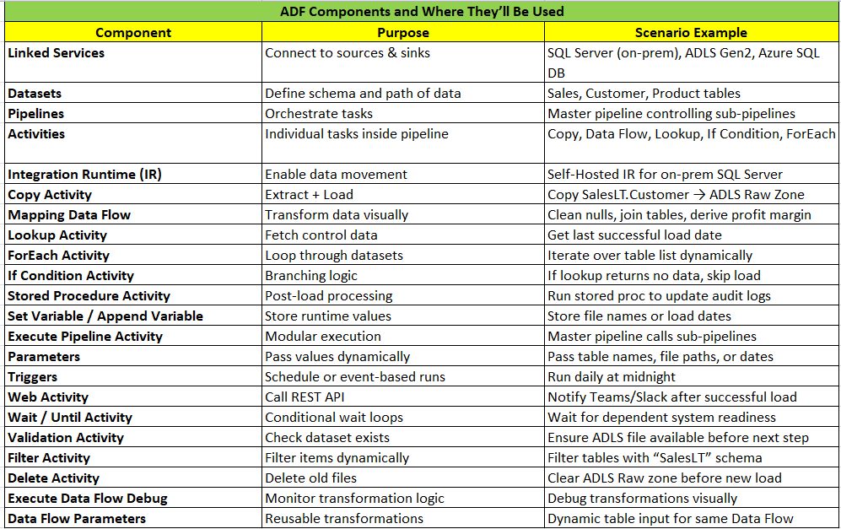

Pipeline Architecture (3-Layer Medallion Style):

1. Bronze Layer (Raw Data)

**Goal:** Extract from SQL Server → ADLS

Tables:

SalesLT.Customer, SalesLT.Product, SalesLT.SalesOrderHeader, SalesLT.SalesOrderDetail

Activities:

* Lookup: Get last load date
* Copy Activity: Incremental load → /adls/bronze/{table}/{yyyymmdd}.csv
* Stored Procedure: Log load metadata

1. Silver Layer (Cleansed Data)

**Goal:** Clean, standardize, and join tables

Data Flow:

* Join SalesOrderHeader + SalesOrderDetail
* Derive TotalAmount, ProfitMargin
* Filter null CustomerIDs
* Sink to /adls/silver/sales/

1. Gold Layer (Aggregated / Reporting Data)

**Goal:** Create curated reporting dataset

Data Flow:

* Aggregate by Customer → Total Sales, Average Order Value
* Sink: Azure SQL Database table dbo.CustomerSalesSummary

Master Pipeline Structure

**Pipeline Name:** PL_Master_AdventureWorksETL

Steps:

1. Lookup Tables List
2. ForEach Table Loop
3. Execute → PL_Bronze_Load
4. Execute Pipeline: PL_Silver_Transform
5. Execute Pipeline: PL_Gold_Load
6. Web Activity: Send Success Notification
7. If Condition (Failure): Send Failure Notification

Optional Enhancements (Advanced)

